 | 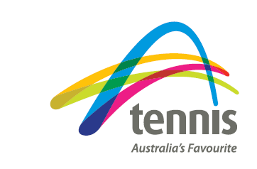  Beaumont Tennis Club  Junior Membership Form: Winter 2026

Member Details – Please add details as required
GIVEN NAME | FAMILY NAME |  | GENDER (male / female / diverse) | DATE OF BIRTH (dd mmm yy)
MAILING ADDRESS |  | PARENT(S)’ NAME(S)
PARENT’S MOBILE PHONE NO. |  | PARENT’S EMAIL
PLAYER’S MOBILE PHONE NO. (OPTIONAL) |  | PLAYER’S EMAIL (IF 15 OR OLDER)

Terms and Conditions and Privacy
‘I agree to abide by the rules of tennis and behaviour codes of the Beaumont Junior tennis group and coaches. This includes dress, language and court etiquette, punctuality and, most importantly, teamwork and good sportsmanship.’
I hereby apply to be a member of Beaumont Tennis Club and agree to be bound by the Beaumont Tennis Club’s constitution and policies (see www.beaumont.org.au/policies.html). I will be bound by the rules, regulations and policies of Tennis South Australia (see www.tennis.com.au/about-tennis-australia/reports-and-policies/policies). I will ensure that I have a Competitive Player Profile. Instructions can be accessed at https://www.tennis.com.au/competitiveplay/create-your-cpp.

Membership Options
A payment is included (fees should be paid before the first match)
☐ | Junior winter competition: | $190
☐ | Junior competition with a Sports Voucher: | $90
☐ | Junior competition with 2 × $100 Sports Vouchers: | $0
☐ | Supplement for also playing Senior winter competition: | $110
Sports Vouchers:
Sports Vouchers may be used on behalf of children up to Year 9 for payment ($100 or $200) towards Beaumont Junior competition membership. See www.beaumont.org.au/membership.html and fill in details on the next page.
Pay by Electronic Funds Transfer:
Make direct transfer to the Beaumont Tennis Club’s bank account: BSB: 105-027 Account number: 129704240. Please include the member’s name in the message field AND provide a filled-in copy of this form to Chris Bagley (Treasurer) or Ben Byrne or Wei Lie (Assistant Junior Coordinators).
Pay by cash:
Please give this completed form and your payment to Chris Bagley (Treasurer) or Garry Byrne (Junior Coordinator).
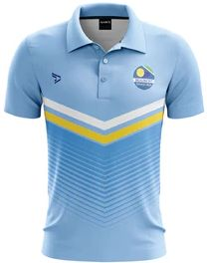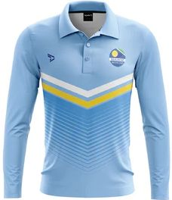 | Club shirts:  Club shirts are available. If you would like one, please order directly from Apelle, apelleapparel.com/collections/beaumont-tennis-club between 27t^{h} April and 11th May. Shirts may be picked up from the Club at no charge.

SPORTS VOUCHER DETAILS:
Additional information is required in order to claim a Sports Voucher.
Child’s information
I confirm my child has not already claimed more than one voucher in 2026 | ☐
Is this the first time your child has joined this activity provider? | Yes ☐ |  | No ☐
Has your child been identified as living with a disability? | Yes ☐ |  | No ☐
Is English the main language spoken at home? | Yes ☐ |  | No ☐
If no, what language do you speak at home?
Is your child from an Aboriginal or Torres Strait Islander background? |  | Yes ☐ |  | No ☐
Medicare information
Medicare number: | _ _ _ _ _ _ _ _ _ _ | Reference number: | _
OR Australian visa number:

